**Tableau**

**Introduction**

Data visualization is a subject that deals with graphical representation of data and Tableau is one of the best data visualizations tools out there. Tableau is one of the easiest data viz tools to use as it doesn’t use any coding, instead tableau employs a very straightforward drag and drop method. That means Tableau can very easily create an interactive dashboard in just a few clicks. Tableau also helps us understand the data and outliers. Furthermore, tableau can connect to over 40 different data sources.

**Data Visualization & Data Cleaning**

To visualize data tableau needs to import the dataset. It can import different types of datasets like Excel, CSV, JSON, pdf, spatial etc. here we import the Walmart retail sample dataset. I tried to use data interpreter to clean the data, but I found it very hard to do so. Since data interpreter doesn’t have any specific way of checking for null values, I had to manually look for them. After importing the dataset, Tableau spontaneously split the data columns in to two parts; As shown in the figure below. Green icons are numerical values (measures) and blue icons are categories.

**Sheet 1: Average profit per state**

On sheet 1 we will try to take a visualise average profit per state on a map. To visualise geospatial data, we will do the following. Firstly, we will drag ‘State’ from the left and drop in on the sheet. To gradient the map by average profit, we drag ‘Profit’ and put it over the ‘Colour’ icon on the ‘Marks’ section, to see average profit right click on ‘SUM(Profit)’ in the marks section -> Then go to ‘Measure (SUM)’ -> click on ‘Average’

For state names to be visible on the map we will drag ‘State’ from the left and drop it on ’Label’ icon on the ‘Marks’ section, The state names will be visible on the map.

For Average Profit to be visible on the map we will drag ‘Profit’ from the left and drop it on ’Label’ icon on the ‘Marks’ section, to see average profit right click on ‘SUM(Profit)’ in the marks section -> Then go to ‘Measure (SUM)’ -> click on ‘Average’. The average profit will be visible on the map.

To change the colour of the states map. We right click on ‘AVG(Profit)’ on the right side of the screen-> then click on ‘Edit Colours’ -> then we select ‘Red green diverging’.

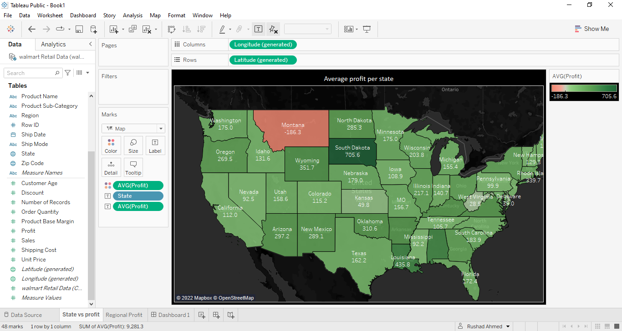

**Sheet 2: Regional Quarterly Average Profits**

On a new sheet we will try to visualize the regional quarterly average profits. We will first drag ‘Region’ from the left and drop it on ‘Rows’ on the top. Then we will drag ‘Order Date’ from the column on the left and drop it in ‘Column’. To see Quarterly we will click on the plus icon(+) on the ‘YEAR(Order Date)’. To see Average Profit we will drag ‘Profit’ from the left and drop it on ’Text’ icon on the ‘Marks’ section, now to see average profit right click on ‘SUM(Profit)’ in the marks section -> Then go to ‘Measure (SUM)’ -> click on ‘Average’. The average profit will be visible in the table.

Right click on ‘Show Me’ in the top right corner and select ‘highlight table’. To change the colour of the tables. We again right click on ‘AVG(Profit)’ on the right side of the screen-> then click on ‘Edit Colours’ -> then we select ‘Red green diverging’.

Note: we can change the background colour of the sheets in ‘Format’ -> then ‘shading’.

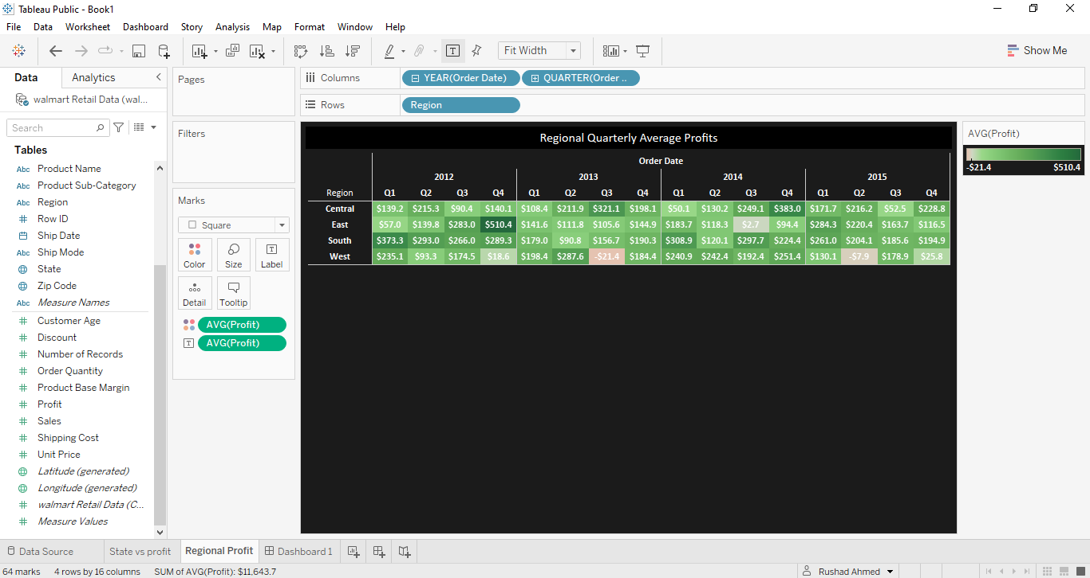

**Dashboard**

To create a Dashboard, we select the option on the bottom of the screen and then we select 'New Dashboard'. In Dashboard we can see there are multiple things to do, we can add more sheets, resize the dashboard etc. Here we simply drag the sheets from the left and drop them, the dashboard is generated. We can adjust the sizes of the sheets in the dashboard and adjust them accordingly.

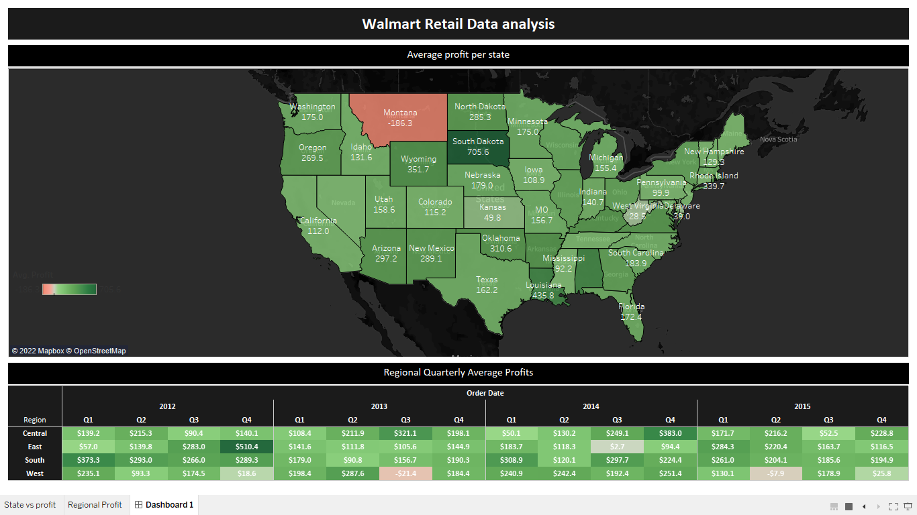

**Insights**

After visualizing the data. We can see that state of Montana is in a loss, whereas states like Kansas, Nevada, Delaware are giving us Low profits. Additionally, States like South Dakota, Wyoming, Louisiana and Rhode Island are Giving very high Profits. Whereas the regional quarterly average profits have fluctuated slightly but have been more or less consistent over time.

**Conclusion**

Tableau is a strong tool to create immersive data visualizations very quickly and with very little effort. It is very easy to use and can handle millions of rows of data without affecting the performance.

My Tableau book Link: <https://public.tableau.com/app/profile/rushad.ahmed/viz/Book1_16488084592450/Dashboard1?publish=yes>